**INFORMATION MANAGEMENT**

AGUBA, REZLYN S.

DE TORRES, PRINCESS ELAINE A.

**BSIS 3**

1. Create Database:

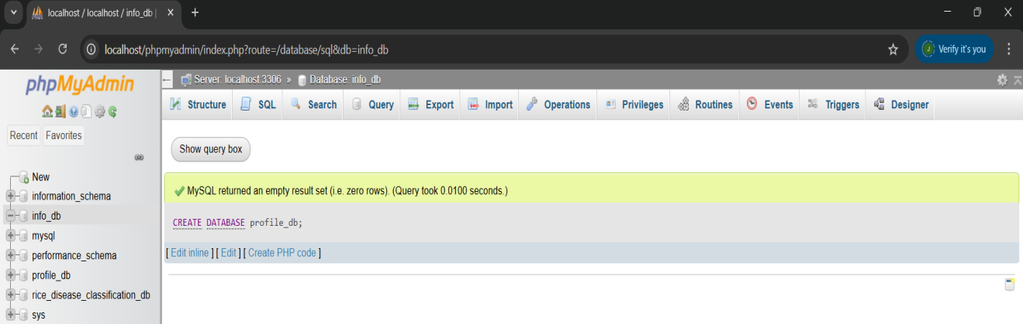

1. Create Table:

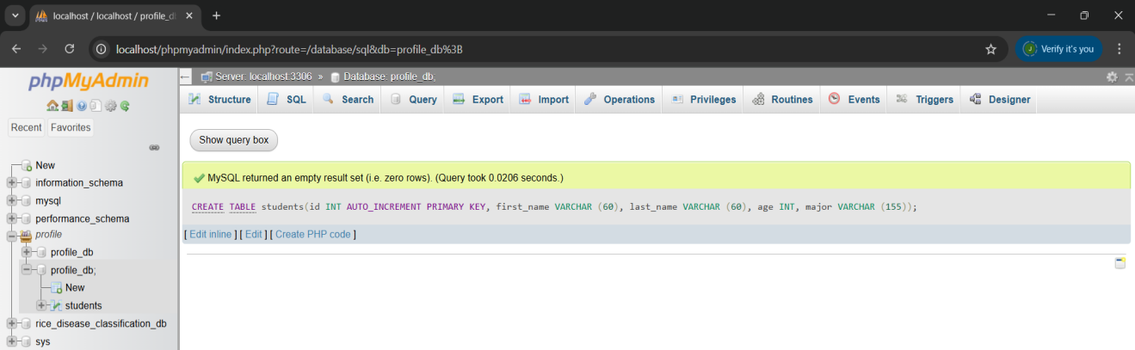

1. Insert data into table:

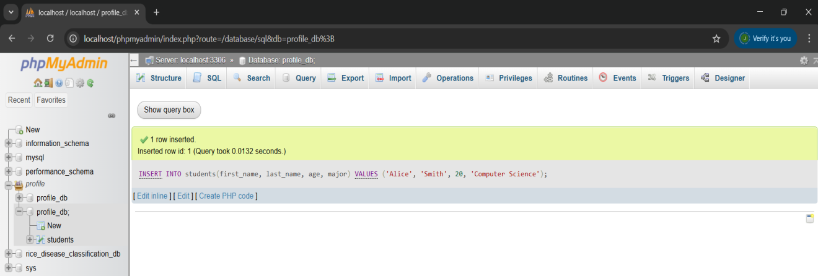

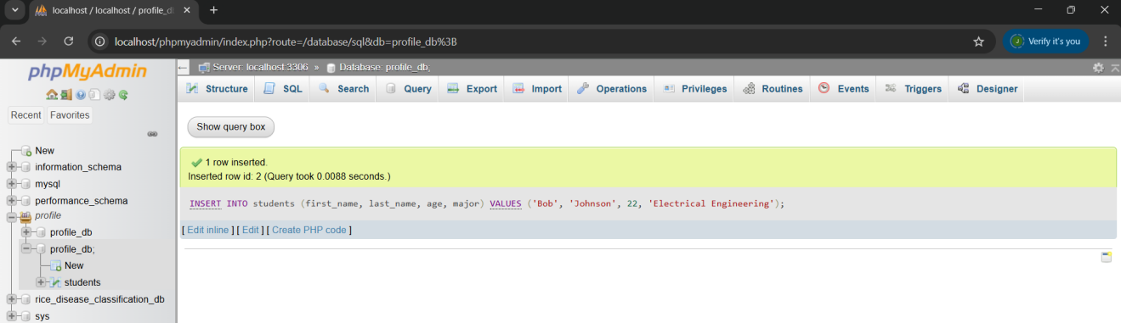

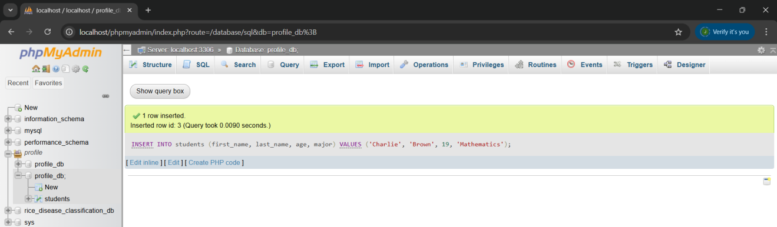

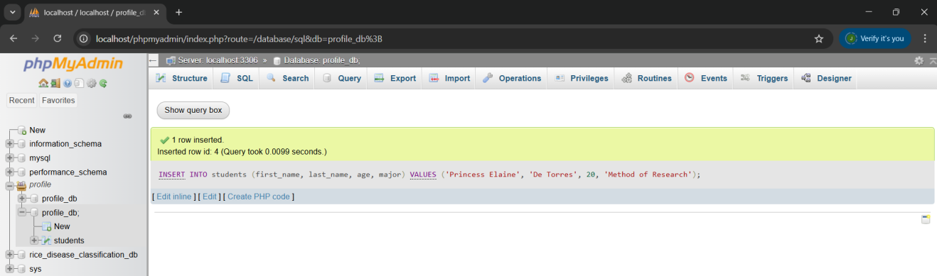

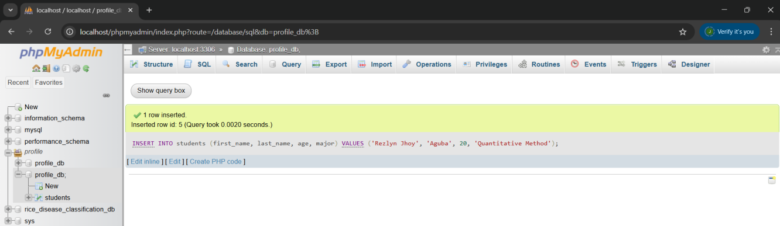

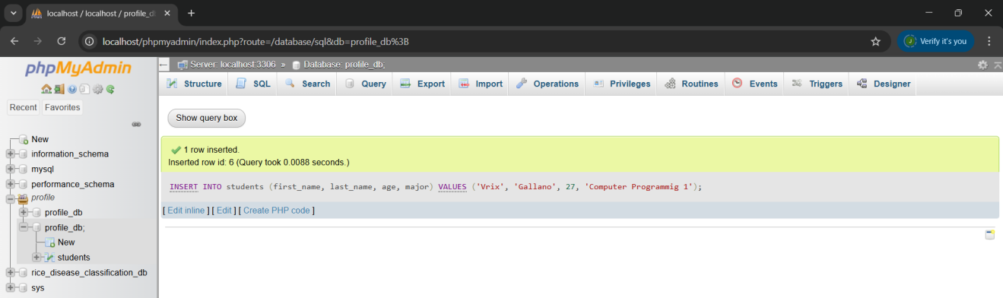

1. Read data using Select:

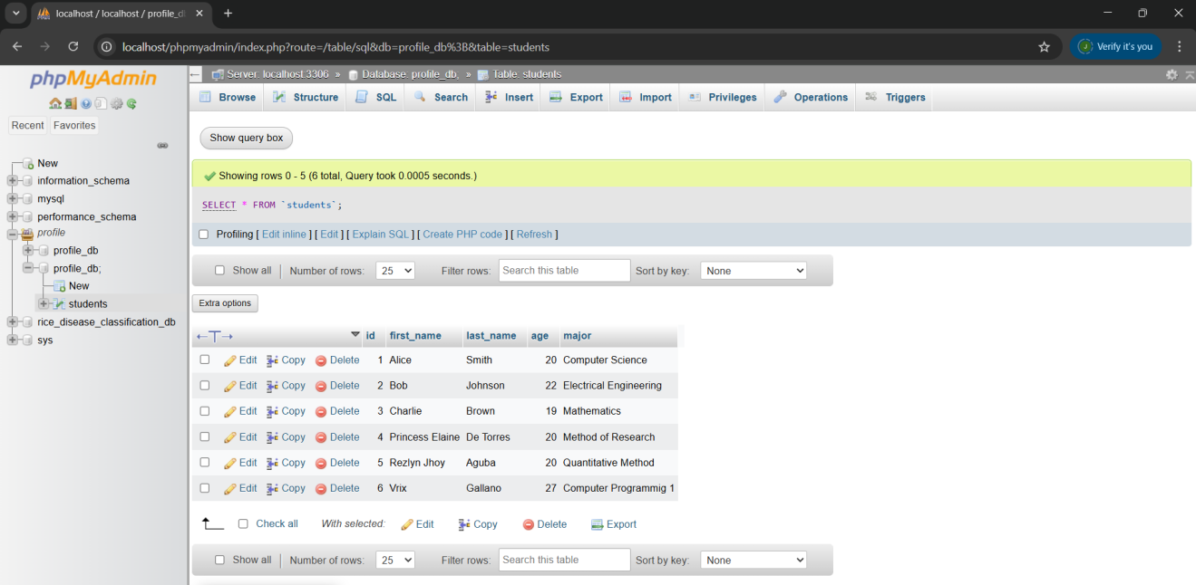

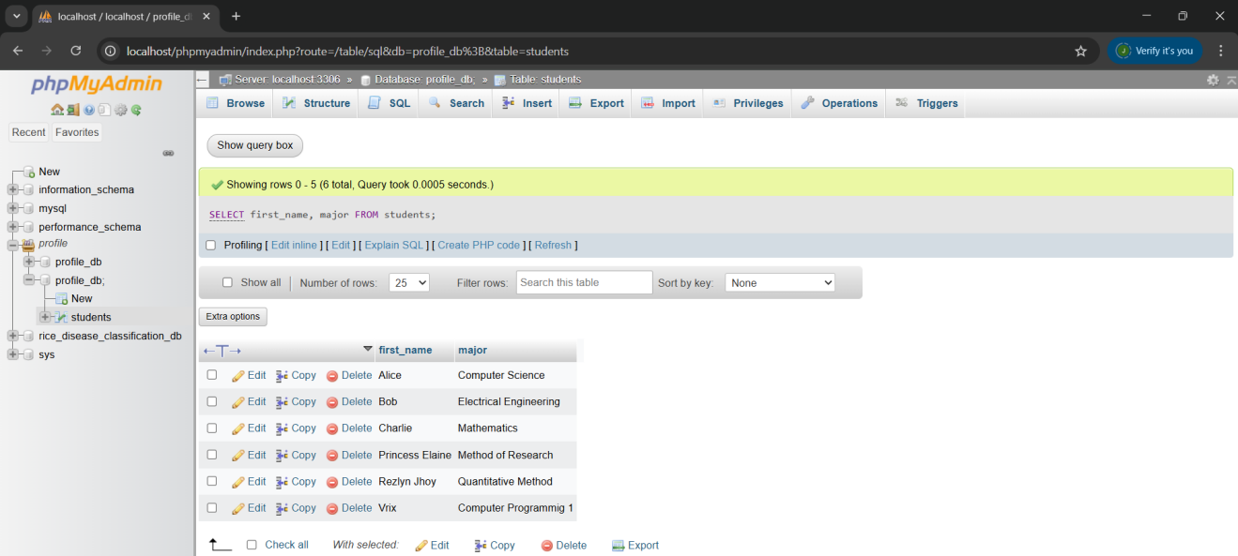

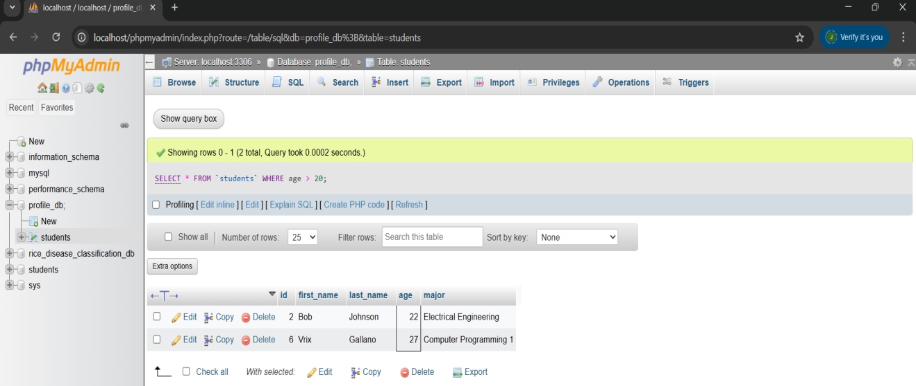

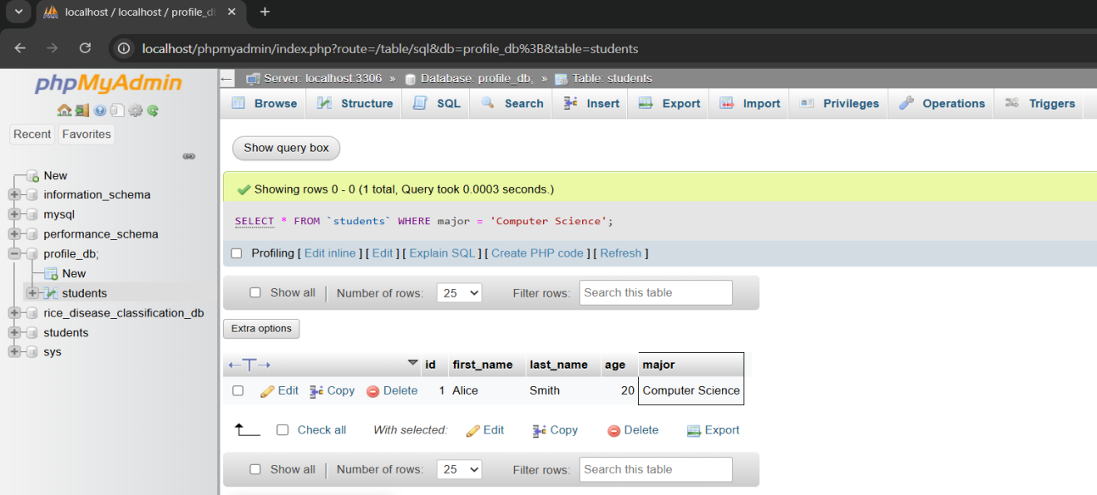

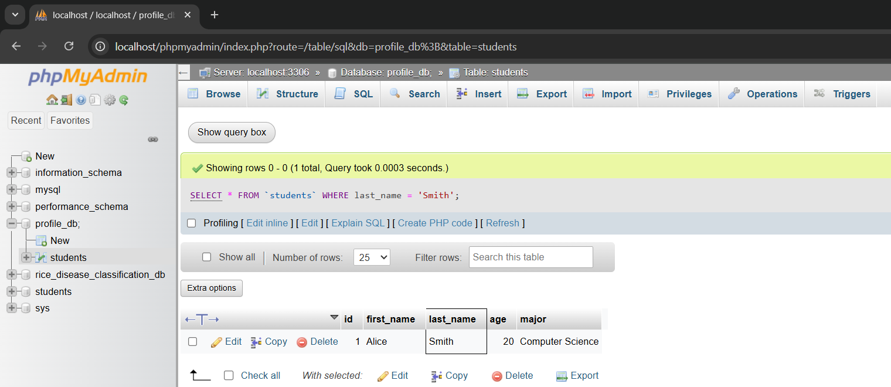

1. Update data:

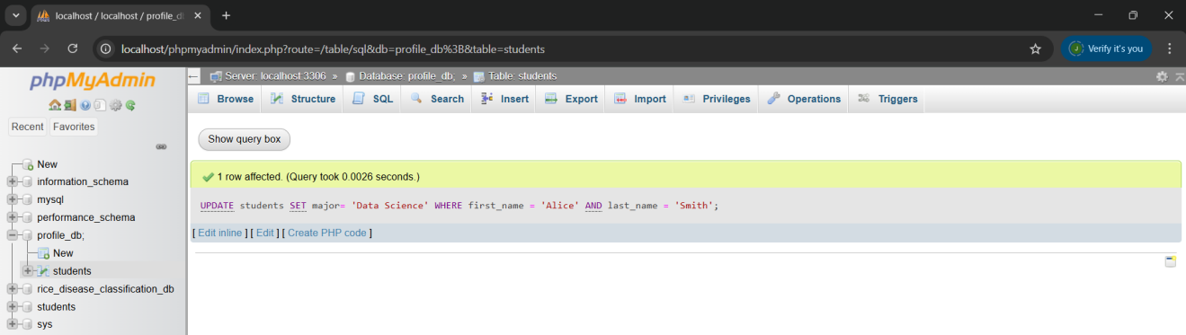

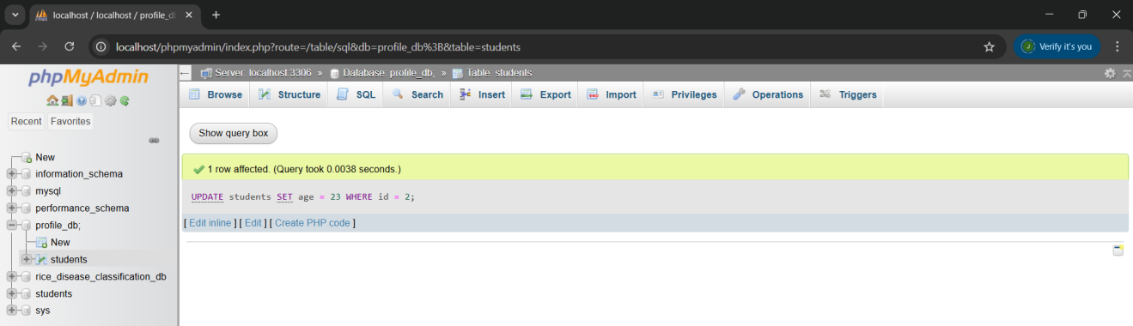

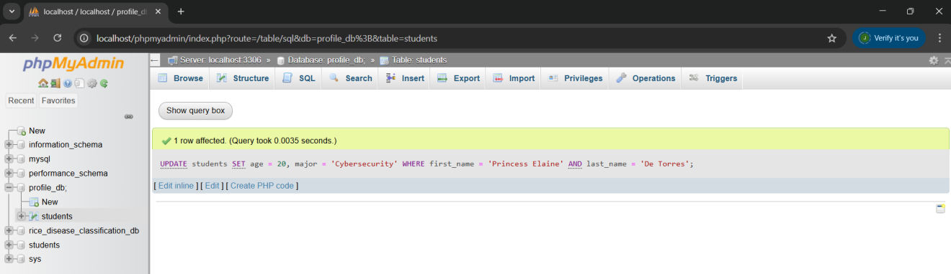

**After each update run, to confirm the changes:**

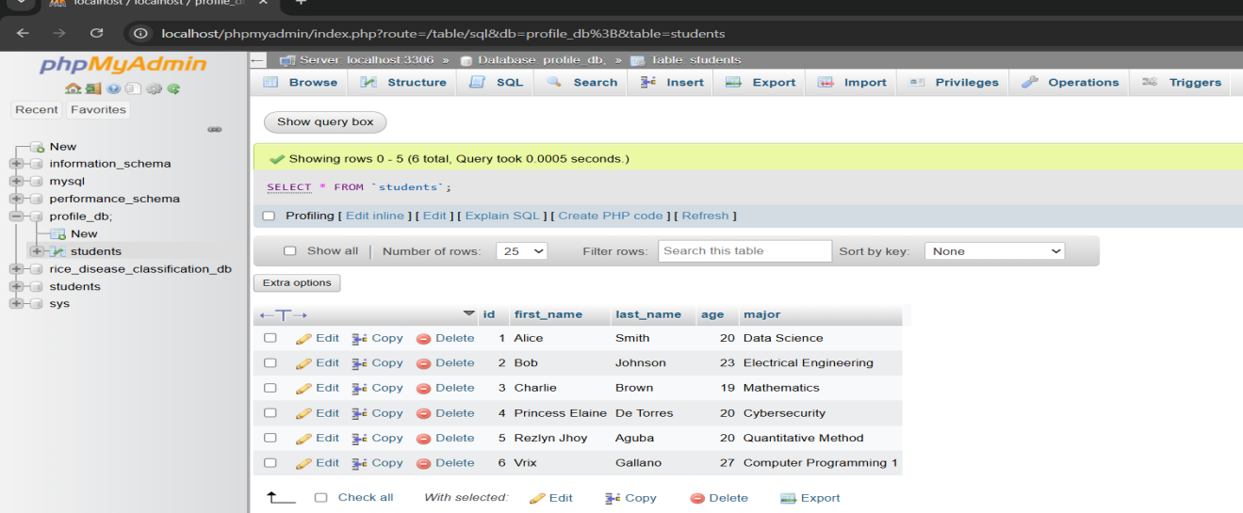

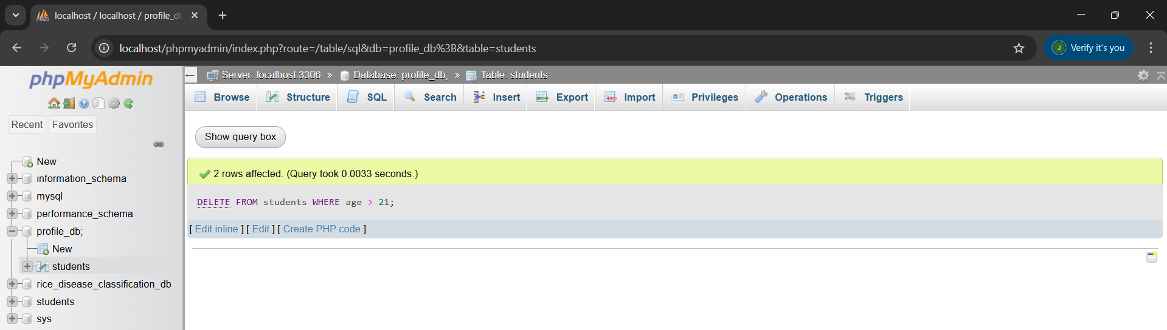

1. Delete the data:

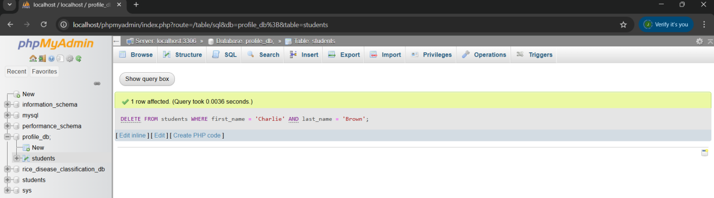

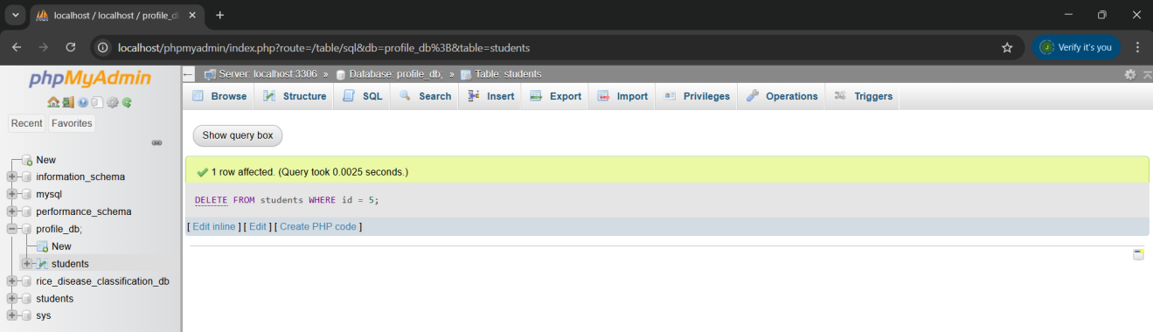



**Short explanation:**

Once you run the INSERT command, you will see that the new students you added appear in the table. Using the SELECT statements, you explore viewing the data. When you apply an UPDATE, you’ll notice the details change instantly. DELETE , the student you removed is gone from the results. This shows how SQL handles each part of CRUD in real time process.